BLAST Analysis of Human Haemoglobin Subunit Beta (HBB): A Sequence Similarity Study
Introduction
Haemoglobin Beta (HBB) is the beta subunit of the haemoglobin group. Generally, haemoglobin is made up of 4 subunits — 2 alpha subunits and 2 beta subunits. These 4 subunits together transport oxygen throughout the body. Therefore, from the function of haemoglobin, it becomes clear that its shape plays a very important role in determining how much oxygen it can carry throughout the body, and any changes to this shape can affect the body. As mentioned, when there is a mutation at the 6th position — from Glu (Glutamic acid) to Val (Valine) — it causes a change in the shape of haemoglobin. The shape changes from globular to rigid and sickle shaped. Due to this change in shape, the haemoglobin molecules stick together and form rigid fibres, causing the red blood cells to become rigid and sickle-shaped. These misshapen cells get stuck in blood vessels, resulting in blocked blood flow and reduced oxygen delivery throughout the body. This makes HBB a valuable model protein for studying how small changes in sequence can have major effects on protein structure and function.
Methods
The HBB protein sequence(accession P68871) was retrieved from UniProt in FASTA format.
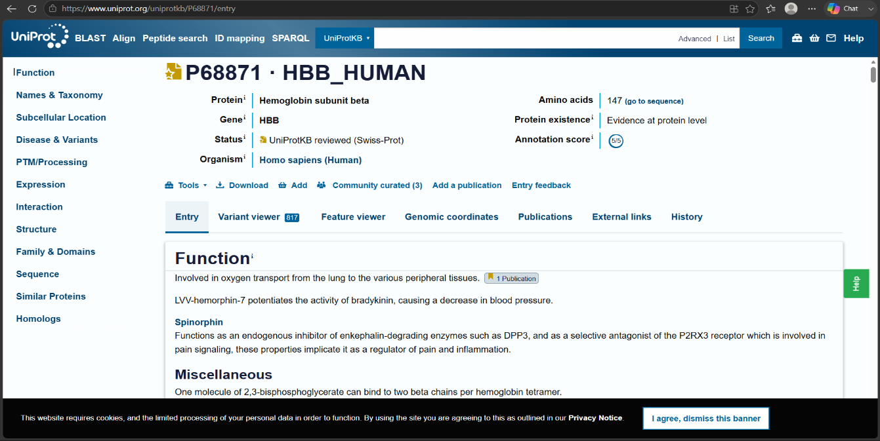
Figure 1: UniProt entry for HBB_HUMAN (accession P68871)
This sequence is then used to run BLASTp search. Instead of directly pasting the sequence format from the NCBI we have used a Python library know as Bio python. It sent sequence directly to NCBI’s server over the internet and requested a search against the non-redundant protein database. NCBI's servers then compared the query sequence against millions of stored protein sequences and returned the top 15 most similar matches. The results were received in XML format, which is not easy to read directly, so a script was used to extract the key values for each hit — percent identity, percent query coverage, E-value, and bit score — and organize them into a clean summary table. A scatter plot of percent identity versus E-value was also generated to visualize the overall pattern of the results.
Results
The BLAST search returned 15 hits, which were categorized into two groups based on their percentage identity: one group with 100% identity, and the other with 99.32% identity. Of the 15 hits, 3 sequences showed 100% identity, meaning these 3 sequences were exactly identical to our query sequence, i.e., the HBB human protein. The remaining 12 sequences were 99.32% identical to the query sequence, meaning 1 amino acid differed out of the same 147 amino acids.
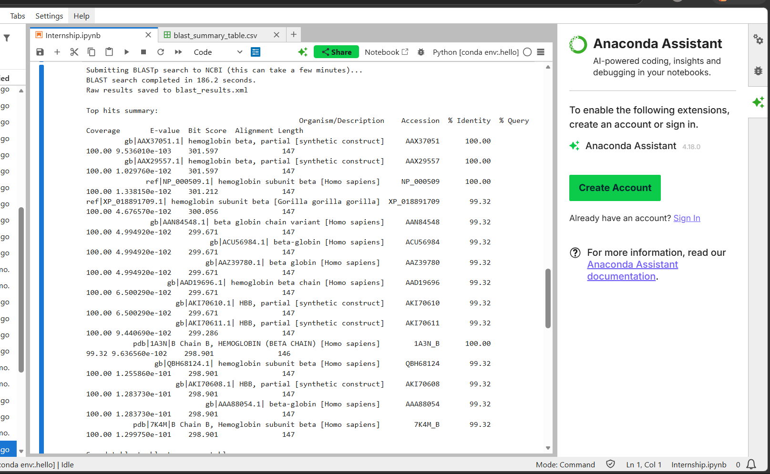
Figure 2: Summary of top 15 BLASTp hits for HBB
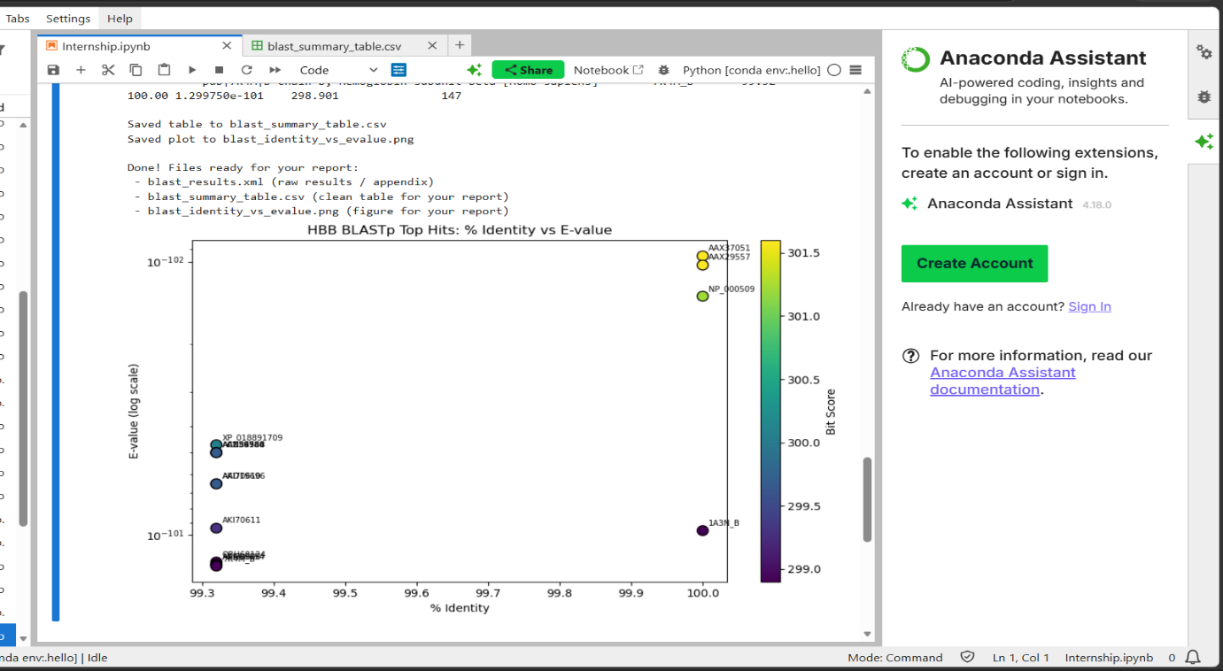
Figure 3: Percent identity vs E-value for top BLAST hits
All 15 hits had extremely low E-values (around 10⁻¹⁰² or smaller), which means all the hits are statistically significant and their occurrence is not due to chance or randomness.
Among the 99.32% identity hits, one match (Gorilla gorilla, accession XP_018891709) showed that haemoglobin beta is nearly identical between humans and gorillas, differing by only one amino acid. Another hit (accession AAN84548) was a human HBB variant, which on closer inspection corresponds to a Glu121Lys mutation, matching a haemoglobin variant called Haemoglobin O-Arab. Two hits (1A3N and 7K4M) were entries from the Protein Data Bank (PDB), meaning they represent real, experimentally solved 3D structures of haemoglobin beta rather than just sequence records.
The full list of results is shown in Table 1, and a scatter plot of percent identity versus E-value is shown in Figure 1.
Discussion
The very similar match between human and gorilla HBB (99.32% identity, differing by only one amino acid) tells us there is strong evolutionary conservation of this protein. Since the HBB protein plays such an important role in oxygen transport in the body, any mutation in this protein can cause harm to the organism. Over millions of years, the HBB sequence has not mutated much, and therefore its sequence has remained conserved across species. This high level of conservation helps explain why the Glu6Val mutation is responsible for causing sickle cell anaemia, a very serious disease. Since the protein has very little tolerance for change, even a small alteration in one position can significantly disrupt its shape and function.
This idea is further supported by the discovery of accession AAN84548, a human HBB variant that carries the Glu121Lys mutation. This haemoglobin variant is known as Haemoglobin O-Arab. This variant was not something that was specifically searched for, but appeared automatically as part of the BLAST search results. This clearly shows how mutations can affect other regions of the HBB sequence, not just the 6th position, and also proves that there are more clinically documented mutations beyond sickle cell anaemia. This shows that HBB is a mutation-sensitive protein, where even a small sequence change can cause significant functional and medical consequences.
In addition to the last two hits, 1A3N and 7K4M were entries from the Protein Data Bank (PDB), representing real, experimentally determined 3D structures of HBB rather than predicted models. These structures provide a direct and reliable starting point for visualizing the actual 3D shape of HBB, and will be used in Task 3 to examine how the sickle-cell mutation (Glu6Val) physically alters the protein's structure.
Conclusion
In this task, a BLASTp search was performed on the human HBB protein sequence using Bio python to run the search against NCBI's non-redundant database. The results show that HBB is a conserved protein, with even distantly related species like gorillas differing by only one amino acid. Due to this high level of conservation, even a small change in the amino acid sequence (like Glu6Val) can cause sickle cell anaemia. The search also revealed a second clinically documented variant, Haemoglobin O-Arab (Glu121Lys), showing that HBB contains multiple mutation-sensitive sites beyond position 6. Additionally, two hits from the Protein Data Bank (1A3N and 7K4M) provided real, experimentally solved 3D structures of HBB, which will be used in the next task to visualize how these mutations physically affect the protein's shape. Overall, this analysis confirms that HBB is a well-conserved, disease-relevant protein, making it a strong candidate for further study through multiple sequence alignment and structural analysis.

